**BANK LOAN ANALYSIS**

1. **BANK LOAN ANALYSIS | SUMMARY**

**Total no of Loan Applications**

select COUNT(id) as Total_Applications from loan_data



**Total no of Loan Applications latest month (MTD)**

select COUNT(id) as MTD_Total_Applications from loan_data

where MONTH(issue_date) = 12



**Total no of Loan Applications previous month (PMTD)**

select COUNT(id) as PMTD_Total_Applications from loan_data

where MONTH(issue_date) = 11



--2. Total Funded Amount:

select SUM(loan_amount) as Total_Funded_Amount from loan_data



select SUM(loan_amount) as MTD_Total_Funded_Amount from loan_data

where MONTH(issue_date) = 12



select SUM(loan_amount) as PMTD_Total_Funded_Amount from loan_data

where MONTH(issue_date) = 11



--3. Total Amount Received:

select SUM(total_payment) as Total_Received_Amount from loan_data



select SUM(total_payment) as MTD_Total_Received_Amount from loan_data

where MONTH(issue_date) = 12



select SUM(total_payment) as PMTD_Total_Received_Amount from loan_data

where MONTH(issue_date) = 11



--4. Average Interest Rate:

select AVG(int_rate)*100 as Average_Interest_Rate from loan_data



select AVG(int_rate)*100 as MTD_Average_Interest_Rate from loan_data

where MONTH(issue_date) = 12



select AVG(int_rate)*100 as PMTD_Average_Interest_Rate from loan_data

where MONTH(issue_date) = 11



--5. Average Debt-to-Income Ratio (DTI):

select AVG(dti)*100 as Average_DTI from loan_data



select AVG(dti)*100 as MTD_Average_DTI from loan_data

where MONTH(issue_date) = 12



select AVG(dti)*100 as PMTD_Average_DTI from loan_data

where MONTH(issue_date) = 11



-- Good Loan

select COUNT(id) AS Total_good_loan_Applications

from loan_data

where loan_status = 'Fully Paid' or loan_status = 'Current'



select (COUNT(case when loan_status = 'Fully Paid' or loan_status = 'Current' then id end)*100)/COUNT(id) as Good_loan_Percent

from loan_data



select SUM(loan_amount) as Total_good_loan_funded_amount from loan_data

where loan_status = 'Fully Paid' or loan_status = 'Current'



select SUM(total_payment) as Total_amount_received_from_good_loan from loan_data

where loan_status = 'Fully Paid' or loan_status = 'Current'



-- Bad Loan

select COUNT(id) as Total_bad_loan_Applications

from loan_data

where loan_status = 'Charged Off'



select (COUNT(case when loan_status = 'Charged Off' then id end)*100)/COUNT(id) as Bad_loan_Percent

from loan_data



select SUM(loan_amount) as Total_good_loan_funded_amount from loan_data

where loan_status = 'Charged Off'



select SUM(total_payment) as Total_amount_received_from_good_loan from loan_data

where loan_status = 'Charged Off'



-- Summary tables

select

loan_status,

COUNT(id) as No_of_Applications,

SUM(loan_amount) as Total_amount_Funded,

SUM(total_payment) as Total_amount_received,

AVG(int_rate)*100 as Average_interest_rate,

AVG(dti)*100 as Average_DTI

from loan_data

GROUP BY loan_status

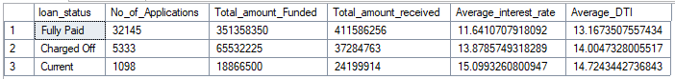

--MTD

SELECT

loan_status as Loan_Status_MTD,

SUM(loan_amount) as Total_amount_Funded,

SUM(total_payment) as Total_amount_received

FROM loan_data

where MONTH(issue_date) = 12

GROUP BY loan_status

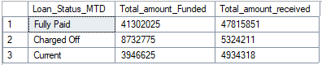

--PMTD

SELECT

loan_status as Loan_Status_PMTD,

SUM(loan_amount) as Total_amount_Funded,

SUM(total_payment) as Total_amount_received

FROM loan_data

where MONTH(issue_date) = 11

GROUP BY loan_status

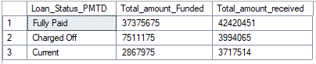

1. **BANK LOAN ANALYSIS | OVERVIEW**

--Monthly Trend

select

MONTH(issue_date) as Month_Number,

DATENAME(month,issue_date) as Month_Name,

COUNT(id) as Total_Application,

SUM(loan_amount) as Total_amount_Funded,

SUM(total_payment) as Total_amount_received

from loan_data

group by MONTH(issue_date), DATENAME(month,issue_date)

order by MONTH(issue_date)

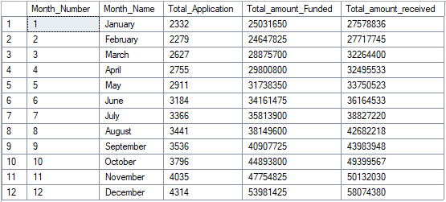

-- Regional Analysis

select

top(20)

address_state as State_Name,

COUNT(id) as Total_Application,

SUM(loan_amount) as Total_amount_Funded,

SUM(total_payment) as Total_amount_received

from loan_data

group by address_state

order by SUM(loan_amount) desc

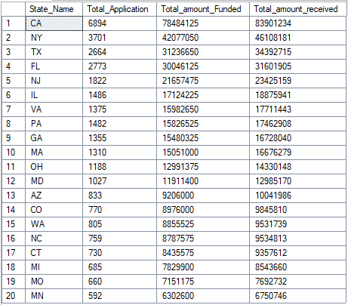

-- Term

select

term as Term_Frequency,

COUNT(id) as Total_Application,

SUM(loan_amount) as Total_amount_Funded,

SUM(total_payment) as Total_amount_received

from loan_data

group by term



-- Employeement Status

select

emp_length as Employeement_Status,

COUNT(id) as Total_Application,

SUM(loan_amount) as Total_amount_Funded,

SUM(total_payment) as Total_amount_received

from loan_data

group by emp_length

order by emp_length

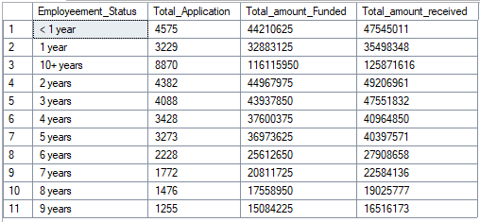

-- Loan Purpose Breakdown

select

purpose as Loan_Purpose,

COUNT(id) as Total_Application,

SUM(loan_amount) as Total_amount_Funded,

SUM(total_payment) as Total_amount_received

from loan_data

group by purpose

order by SUM(loan_amount) desc

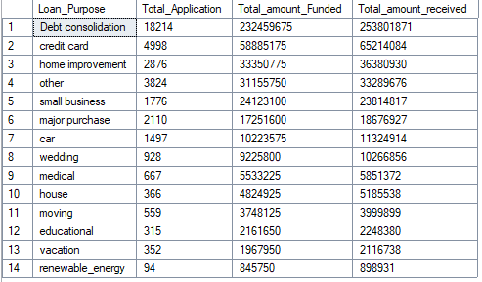

-- Home Ownership

select

home_ownership as Home_Ownership,

COUNT(id) as Total_Application,

SUM(loan_amount) as Total_amount_Funded,

SUM(total_payment) as Total_amount_received

from loan_data

group by home_ownership

order by SUM(loan_amount) desc

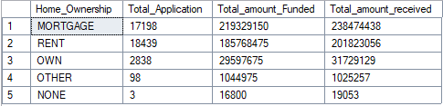

-- Filtering

select

home_ownership as Home_Ownership,

grade as Grade,

COUNT(id) as Total_Application,

SUM(loan_amount) as Total_amount_Funded,

SUM(total_payment) as Total_amount_received

from loan_data

where

grade in ('A','B')

and

address_state = 'CA'

group by home_ownership, grade

order by grade, SUM(loan_amount) desc

